Project/App Title

TotalGig

Its about sorting out your gigs easily so you can focus on the creativity and we can focus on the tedious.

Project/App Summary

TotalGig is an online cloud based freelance business management solution for small buisness that have service providers. It is designed to enable one or a few users manage personnel, equipment inventory, and job schedules in one convienant program. TotalGig will allow an employer to track availability of subcontractors, manage contracting and invoicing automadically. Set periodic reminders for project progess. Complete Ecommerse and employee payables through the application as well.

Everything you need from start to finish to complete your job, besides the labor and the tools.

Twist

TotalGig is different from other solutions because it is specifically catered to the “Freelancer working with other freelancers” situation. This situation is common for photogtaphers, web designers, graphic artists, musicians, and countless other jobs. This solution isnt a tacked on helpful feature of an application with a different purpose like you will find in calendar apps associated with email. It is a full featured, independent website designed to keep you focused and on task with the paperwork side of your creative job so you can spend as little time as possible working on this boring part of your job.

4 Week Schedule

Week 1 Research and develop. Client Interview.

Monday-Tuesday: Read assignment directions for all assignments. Consult with students previously in this class to get an idea what this class is about. Pick framework that I will use in my app.

Wednesday: GoToMeeting to clarify final questions about assignment. (Meeting never happened. Waited 40 min after start time.

Thursday: Potential user interviews. I selected 2 freelancers in the photography/videography industry, explained the concepts of my application and asked them a series of questions and feature sets that would and wouldent be necessary in their workflow.

Friday : Create PRD document and plan project deadlines.

Week 2 Basic Design/ CRUD / User Login

Monday-Wednesday: Create an extremely basic HTML page and link all files for framework. Make basic crud system for my app. Enable user regristration and login/logout functions with sessions.

Thursday: Testing and code refinement

Friday: Improve design, complete any persistant issues identified in testing.

Week 3

Monday-Wednesday: Email notification from the website when employee is booked for a gig. Add ability to upload files for employees

Thursday: Testing and code refinement

Friday: Improve design, complete any persistant issues identified in testing.

Week 4

Monday-Wednesday: Enable calendar integration and contract export capability

Thursday: Testing and code refinement

Friday: Improve design, complete any persistant issues identified in testing.

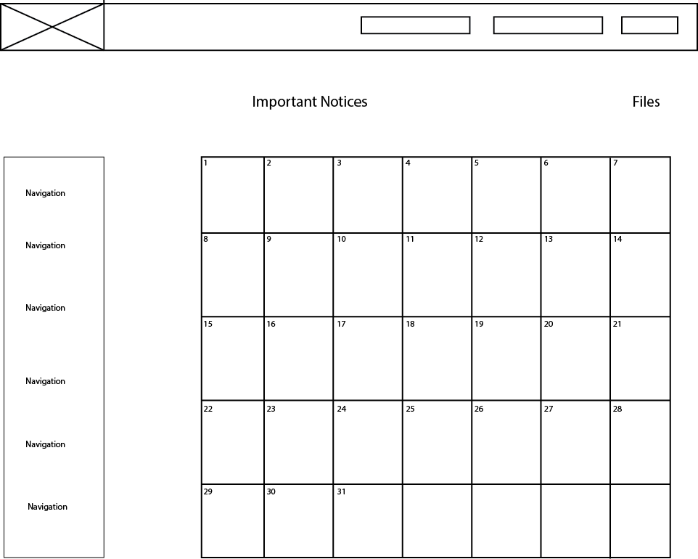

Wireframe

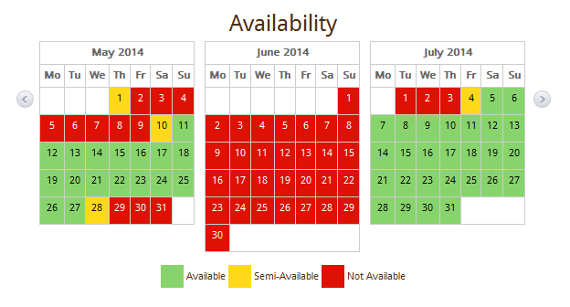

Design Templates

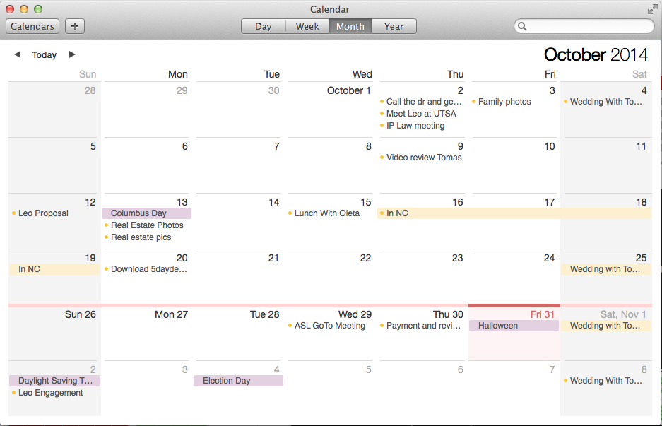

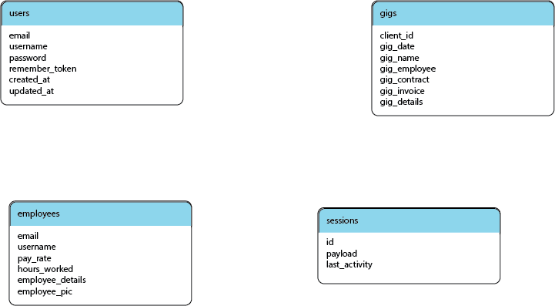

Database Diagram

Language and Framework

I have chosen the Laravel framework. It is a PHP framework that is built upon the preexisting Symfony components. It is a framework built with MVC in mind. I chose this framework because I allready somewhat familiar with it since I used it in a previous assignment. One of the reasons I origionally chose it is because it is the most popular PHP framework used when I made my decision and I figured power with numbers was a safe choice. Another perk was the aformentioned design framework as I am not that great at the design stuff.

**Version 1: At the end of week 4 I will have delivered on all that I have promised. It will be a functioning site capable of handling some of the tasks required to make a freelancers job easier.**

**Version 2: I would do more automation. Have the website handle all messages to and from the client and the employees. Add a wizard interface with popups and suggestions for next steps to take with the client.**